Jenkins Practical Flow – A Bonsai Doc.

Initial run:
- Redirect to D:\Jenkins. This folder contains jenkins.war.
- Open cmd and run `java -jar jenkins.war`.
- This will give you a temporary admin password.
- Install suggested plug-ins.
- Create an admin account.
- Install all of the listed plug-ins.

Manually installed plug-ins:
Docker:
Docker Pipeline
Docker Plugin
docker-build-step
Sonar:
SonarQube Scanner for Jenkins
MsBuild(Not necessary):
MSBuild Plugin
Graph:
Pipeline: Stage View Plugin.

Sequential runs:
- Use `java -jar jenkins.war`
- And use the credentials you have made.
Configurations

Tools:

1. JDK Installations:

Name
Default JDK

JAVA_HOME
C:\Program Files\Java\jdk-17

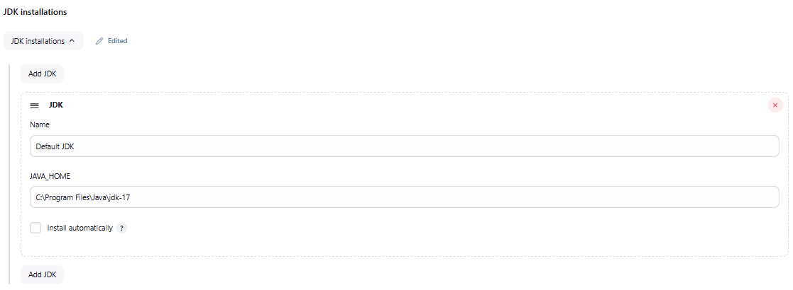
2. Git:

Name
Git

Path to Git executable
C:\Program Files\Git\bin\git.exe

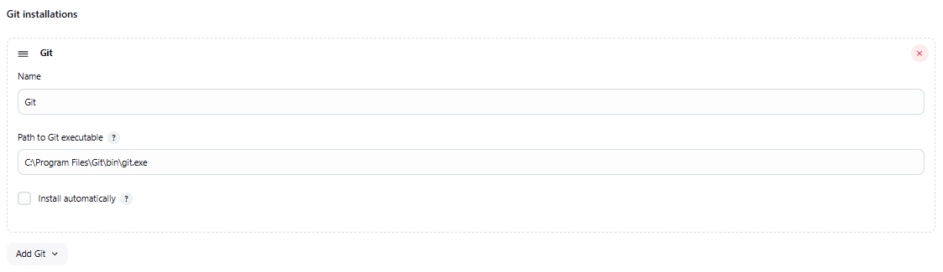
3. MSBuild Installations:

Name
MSBuilder

Default parameters
C:\Program Files\Microsoft Visual Studio\2022\Professional\MSBuild\Current\Bin

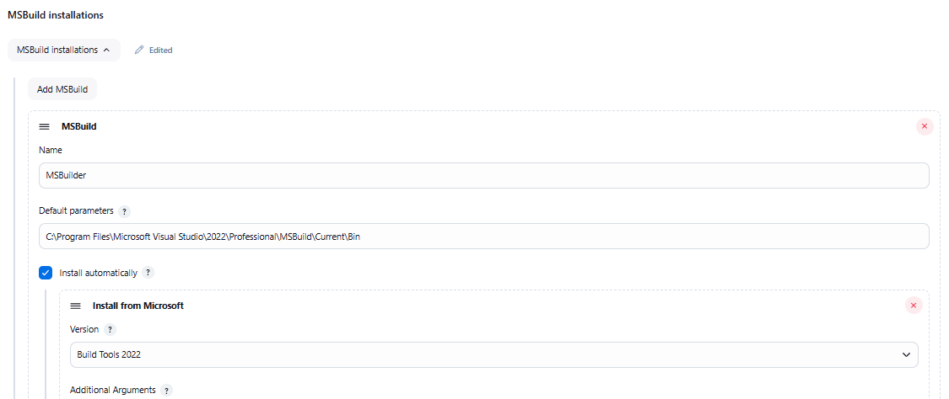
4. SonarQube Scanner:

Name
MySonar

SONAR_RUNNER_HOME
D:\sonarqube-25.1.0.102122\sonarqube-25.1.0.102122

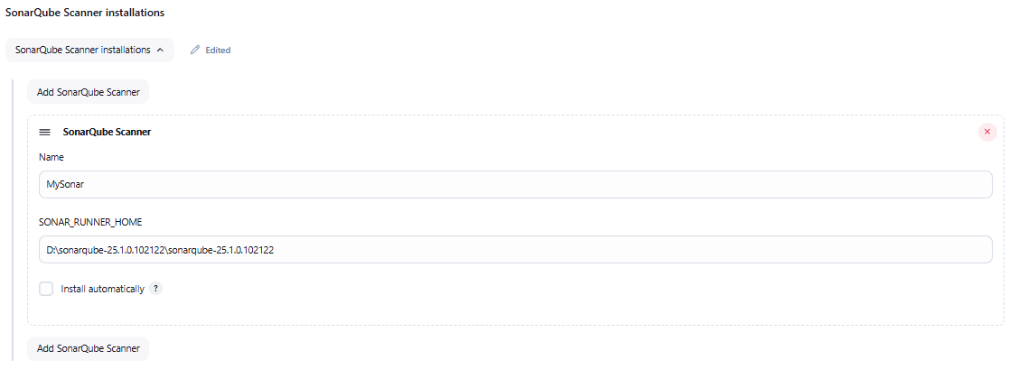

5. Docker:

Name
Docker

Installation root
C:\Program Files\Docker\Docker

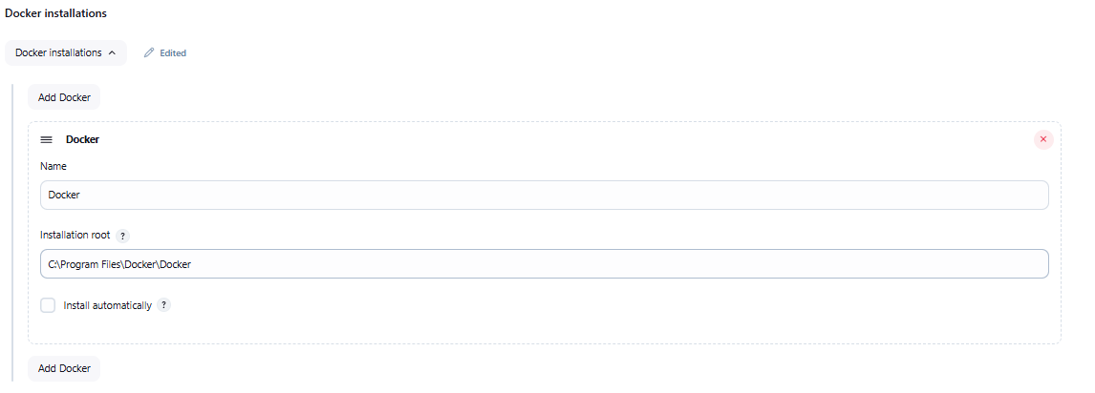
System:

Set during the initial run:

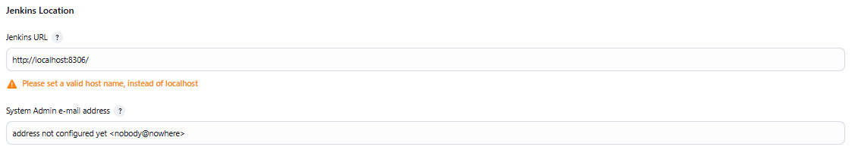

SonarQube Servers:

Name
Sonar URL

Server URL
http://localhost:9000

Server authentication token
- none -

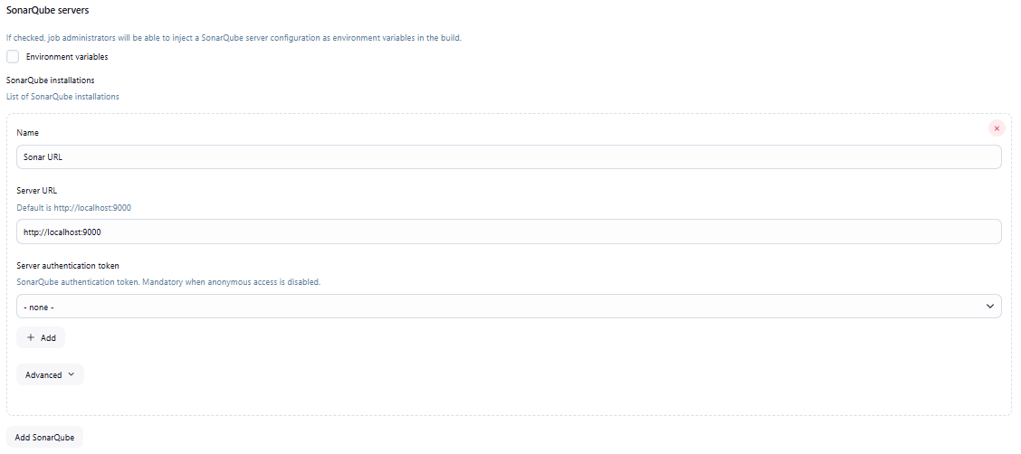

Declarative Pipeline (Docker):

Docker Label
MyDocker

Docker registry URL
tcp://localhost:2375

Registry credentials
- none -

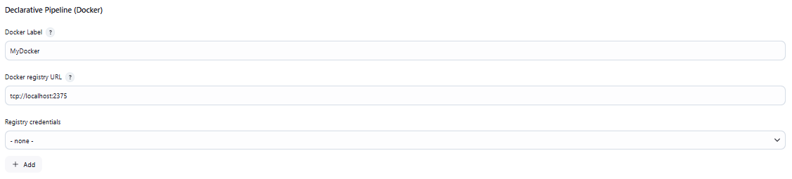
Practical Flow:

- Create or have any project you already have with the following requirements:
  - One fully functional project: Console App, Web API or MVC Razor Page.
  - One Nunit template-like testing project.
  - DockerFile for the main project alone.
- Push code into a public repo.
- Create a pipeline job in jenkins.
- Write the pipeline script.

Full Script:

node {
stage("Git Checkout") {
git "https://github.com/BonsaiPlays/JenkinsTrainerFantasyWebApp.git"
}
stage("Build Project") {
bat "dotnet build FantasyWebApp/FantasyWebApp.sln"
}
stage("Test Project") {
bat "dotnet test FantasyWebApp/FantasyWebApp.sln"
}
stage("QA") {
bat 'dotnet sonarscanner begin /k:"FantasyWebApp" /d:sonar.host.url="http://localhost:9000" /d:sonar.token="sqp_f366fa66c75dca587a266b0d0e51d1a370b9a474"'
bat "dotnet build FantasyWebApp/FantasyWebApp.sln"
bat 'dotnet sonarscanner end /d:sonar.token="sqp_f366fa66c75dca587a266b0d0e51d1a370b9a474"'
}
stage("Docker Containerization") {
dir("FantasyWebApp/FantasyWebApp") {
bat '''
for /f %%i in ('docker ps -a -q --filter "ancestor=pipeline"') do docker rm -f %%i
docker rmi -f pipeline
docker build -t pipeline .
docker run -d -p 8083:8083 --name pipelinecontainer pipeline
'''
}
}
}
Pipeline Script Line by Line:

1. Pull latest code from your repoo:

stage("Git Checkout") {
git "https://github.com/BonsaiPlays/JenkinsTrainerFantasyWebApp.git"
}

2. Direclty build your project:

stage("Build Project") {
bat "dotnet build FantasyWebApp/FantasyWebApp.sln"
}

3. Test your project with the Nunit Tests:

stage("Test Project") {
bat "dotnet test FantasyWebApp/FantasyWebApp.sln"
}

4. Run SonarQube and have the code analysed.
Have the regular run of SonarQube done to get the commands.
Have the commands in the single quotes.

stage("QA") {
bat 'dotnet sonarscanner begin /k:"FantasyWebApp" /d:sonar.host.url="http://localhost:9000" /d:sonar.token="sqp_f366fa66c75dca587a266b0d0e51d1a370b9a474"'
bat "dotnet build FantasyWebApp/FantasyWebApp.sln"
bat 'dotnet sonarscanner end /d:sonar.token="sqp_f366fa66c75dca587a266b0d0e51d1a370b9a474"'
}

5. Docker Stage:

stage("Docker Containerization") {
dir("FantasyWebApp/FantasyWebApp") {
bat '''
for /f %%i in ('docker ps -a -q --filter "ancestor=pipeline"') do docker rm -f %%i
docker rmi -f pipeline
docker build -t pipeline .
docker run -d -p 5306:5306 --name pipelinecontainer pipeline
'''
}
}

dir("FantasyWebApp/FantasyWebApp")

Redirects into the project file, I need to use it twice.
Most for most people using once is working fine: dir("FantasyWebApp")

for /f %%i in ('docker ps -a -q --filter "ancestor=<imageName>"') do docker rm -f %%i

Simillar to a for-each loop in the windows batch scripting, goes through all the containers to filter out container made using a particular image file and delete them one after the other.

docker rmi -f <imageName>

Delete the image file.

docker build -t <imageName> .

Create new image.

docker run -d -p <port>:<port> --name <containerName> <imageName>

Create and run a container based on the image created. The port much match the port mentions in the docker file.

bat ``` ... ```

Allows you to run multiple bat commands in sequence.
Docker File:

# Build stage

FROM mcr.microsoft.com/dotnet/sdk:8.0 AS build

WORKDIR /src

# Copy the project file and restore dependencies

COPY FantasyWebApp.csproj ./

RUN dotnet restore

# Copy the rest of the source code

COPY . ./

RUN dotnet publish -c Release -o /app/publish

# Runtime stage

FROM mcr.microsoft.com/dotnet/aspnet:8.0 AS runtime

WORKDIR /app

# Copy published output from build stage

COPY --from=build /app/publish .

# Expose port 5000 for the API

EXPOSE 5306

# Set environment variable for ASP.NET Core to listen on port 5000

ENV ASPNETCORE_URLS=http://+:5306

# Run the application

ENTRYPOINT ["dotnet", "FantasyWebApp.dll"]

